Inquiry Curriculum context planning form
Title:
Animal Park
A wildlife protection centre with a history of caring for injured, sick and endangered animals before returning them to the wild. The park rangers prepare for the arrival of new animals from a zoo where they have not been so well looked after.

Context:

An experienced team of animal park rangers are commissioned to prepare for the arrival of a shipment of animals from a zoo which has been forced to close due to lack of funds. The zoo’s owner is concerned that the animals are properly cared for and are not hurt or distressed in the move.
The owner did what she could for the animals while they were in her care, but recently has found it very difficult to provide the highest quality of care the animals deserve. As a consequence some of the animals are reported to be ill, undernourished or injured.

In contrast, the team’s wildlife park is a model of care, consideration and protection. The park has a long and successful history of caring for injured, sick and endangered animals and is proud of its record of returning as many of them as possible safely back to the wild.

However, the new arrivals will put strain on the park’s resources and the rangers will have to be careful not to unbalance or upset the existing animals. The owner of the animal park will also need reassuring that the new arrivals will not disrupt things too badly.

Main Curriculum areas:
Science Sc1: Scientific enquiry
- Ideas and evidence in science
- Investigative skills
- Planning
- Obtaining and presenting evidence
- Considering evidence and evaluating
Science Sc2: Life processes & living things
- Life processes
- Humans & other animals (KS2: Nutrition, circulation, movement, growth & reproduction, health)
- Green plants (KS2: Growth & nutrition, preproduction)
- Variation & classification
Living things in their environment (KS2: Adaptation, feeding relationships, micro-organisms)

Overview:
Author: Tim Taylor
Theme: Animal welfare & protection
Age Range: EY to KS2
Main curriculum focus: Science: SC2: Humans & Other animals
Inquiry Question: “What are our responsibilities to preserving and protecting endangered animals?”
Expert team: Animal park rangers
Client(s): The owner of a zoo
Commission: To preserve and protect endangered animals and reintroduce them to their natural environments
Inquiry Questions: (There can be a range of inquiry questions, please indicate the main or core ones. The following headings may help, don’t feel obliged to create a question for every category.)

Environmental: How can the environment be managed sustainably and why is this important now and in the future?

Critical: Can animals from zoos be returned safely to their natural environment?
Ethical: What are our responsibilities to preserving and protecting endangered animals and other species?

Philosophical: What should we sacrifice to protect other animals and the planet?
Biological: What do human beings and other living creatures need to survive and flourish?

Steps in: Please include at the beginning a list of resources. Guide people through the first steps into the context, holding their hand along the way. Roughly 10 - 12 steps should be about right. Include the following:

1. The convention being used
2. The language of the teacher (particularly the questions)
3. The use of role and its purpose
4. The activities/tasks being done by the students (iconic, symbolic, enactive)
5. Resources
6. Short notes explaining your thinking

Resources:
- A stack of A5 paper
- Animal project books on the classroom tables
- A collection of resources to make the animal park - i.e. ropes, hoops, lego, large sheets of paper, art straws etc.
- The list of places in the park (see resources list at the end of this planning unit) printed and cut out.
- The newspaper clipping about the closure of the zoo (see resources list at the end of this planning unit) printed and cut out
- The animal facts cards

1. Sitting with the children… the ‘problem-free’ question...
Question: “I wonder, if you had a job, looking after animals... in an animal park… what kind of animal would you most like to care for?”
Give the children chance to answer. Ask some follow up questions, in a conversational way, its important not to interrogate them…
“Ah, a dog. Any kind of dog in particular? What about a horse, is there anyone who would like to look after the horses?”

2. Moving into the context…
Question: “Do you think we should have any large animals?”
Its important here to start talking ‘inside’ the fiction. Notice the switch to ‘we’ as you start to build the team first through the language of collaboration.
“Is anyone prepared to feed and care for the tigers?”
“Yes. I see. I guess you have to be careful with the big cats. Do you think you’d need any special equipment? I don’t know, like gloves?”
“You wouldn’t mind getting close? OK”
“I’m guessing not everyone is keen on the big animals. What else would people like to look after? What about pets? Do you think we might also look after small animals in the park, like rabbits or hamsters?”

3. Inventing the animals… (Resources: A5 paper and project books on the tables)
Task: “Um, we have a lot of animals here… I think it might help if found out just how many we’re dealing with. Could you please grab a piece of paper from the pile here and draw the animal or animals it is your job to look after in the park. You might find the project books on the tables helpful…”

4. Scaffolding their work…
Tasks: As the students draw go round the room looking at their pictures, ask them a question or two about their work. Give support to any that need it… suggest the books if they are stuck.
Then as they work:
(1) “Sorry, I know you’re busy… but can you look this way. Thank you. Could I please ask you to make a note of the kind of animal you’re caring for. It’ll be very helpful, just write next to it what it is… you know a tiger…”

Steps in continued:
Later:
(2) “Sorry, everyone. Could you also draw or write on your picture what your animal eats and drinks… I don’t know if its a meat eater or a vegetarian. But could you just make a quick note… thank you.”
Later:
- “Team… could I please ask you also to draw on your picture where your animal or animals are kept. If they in a tank or an enclosure… Perhaps there’s a high wall or a moat to keep people safe…”
Notice, once again, how the slight shifts in language ‘bring-in’ the idea that we are a team and that the extensions to the tasks are developing the context and creating the team’s responsibilities.

5. Building the park… (you’ll need a collection of resources for the children to make the animal park - i.e. ropes, hoops, lego, large sheets of paper, art straws etc.)
Tasks: To represent the park by using the material and resources listed above. Encourage the children to think about the happiness and welfare of the animals.
Ask them questions as they work (from ‘inside the fiction): “Ah, this is interesting. Could you please explain to me how this works. Um… I see. And do you find this is something that regularly happens?”
Or: “I’m sorry to stop you working… would you mind if I asked you a question about your shark tank… I see, and do they eat a lot of fish? How do you manage to keep them fresh? Um, that makes sense… and do you have to have them delivered every day?”
Etc.
Note: The design of the park is very much in the children’s hands, its important not to impose our adult ideas of what a real park would be like. At this stage the children are representing their ideas and developing ‘ownership’ of the context. See at the end of the planning unit some photos of children’s work.

6. Extending the children’s learning… (you’ll need the list of places in the park (see resources list at the end of this planning unit) printed and cut out. You might also like to take a look at the PDF map of Colchester zoo.
Task - reflection: Sit with the children looking at the animal park… make some comments, avoid unnecessary or insincere praise…
“Its interesting how you designed the hippo enclosure, they are very private animals… I should think that will give them just what they need…” Etc...
Task: “I wonder if you could help me decide where these places go… I’ve cut them out as you can see… how about this one: “Visitor’s car park”. What do you think?”
Read and hand them out one at a time, allow the students to make the decisions. There maybe some discussion and disagreement.

7. First Client - the owner of the condemned zoo
In this context their two main clients. The first client is the owner of a zoo that is about to close and needs the animals moved to a suitable new environment. The second client is the owner of the animal park who will be introduced later (see step...).
The first client in this step will be represented by an adult in role. If you don’t have another adult then you could represent the role yourself, although it would be a bit more difficult.
The first client is the owner of a zoo that is about to be closed, she/he loves her animals but has been unable to maintain the zoo in the way she would like. After a recent inspection the zoo has been given a notice to close and find suitable new homes for the animals. It is important not to portray the owner of the zoo as a ‘bad’ person, but rather as someone who, while meaning well, has found it impossible to fulfill her obligations and now needs help.

Steps in continued:

Introducing the client:
- Show students the newspaper headline - “Zoo soon to be closed after critical report” (see resources below)
- Ask them what they make of it, help out when needed. There might be a bit of confusion if they think its ‘our zoo’, reassure them its not. “Yes, I can see why you might think that. But this headline is not about our animal park, but about a zoo that isn’t run as well. I’m not sure all the animals are well looked after.”
- “Well you can the see the situation. Perhaps we could see how the owner of the zoo is feeling about it. Could we ask Mrs Brown If she wouldn’t mind representing the owner.
- The adult comes round and stands behind a chair ready to sit down. It is important to go quite slow at this point, particularly if the children are not familiar with adults in role.
- “When Mrs Brown sits down she is going to be the owner of the zoo, sitting in her office. The table could be a desk. We’ll need to put the newspaper on the desk, because thats what she has just been reading.” One of the students can do this. “Now, Mrs Brown could you please sit at the desk and we’ll see how the owner of the zoo is feeling right now.” Mrs Brown sits at the desk and immediately puts her head in hands, yes down, looking at the headline.
- “Um, what do you think?” Keep the zoo owner in the convention that we can talk about her but she can’t hear. Talk to the children about their thoughts. When you feel it is the right time change the convention...
- “Excuse me. Would you mind if we talked to you? We can see you are very unhappy. Is it about zoo closing?” “ Yes. Have you heard? I’m so sad. I’ve had this zoo for ten years. Many of the animals here were rescued animals, from all kinds of places.”
- Allow the students to talk to the zoo owner. Try not to interrogate, she’s very upset. During the resulting dialogue the zoo owner needs to relay the following information: (i) Many of the animals have difficult lives, perhaps been maltreated, or orphans, or rescued from hunters; (ii) she cares very much for the animals and wants to see them in suitable new homes; (iii) the zoo failed because, although she meant well, the jobs was too difficult for her.
- It is likely the students will offer to take her animals to their park. If they don’t then introduce the idea yourself. “Well perhaps, we could take your animals. We’re very busy but I’m sure we can find good homes for them.”
The owner agrees in principle but would like to take a visit the park first. Could they arrange for her to visit?

8.The first client visits the animal park
It is agreed that the zoo owner will visit the park. The students/rangers now have to prepare for the visit. They will need to consider the following:
- How to guide her round to see everything
- How to show her how the animals are cared for
- How the animals are looked after when they are ill or injured
- Etc
When preparing for the visit you can decide how much time you want to give to the project. There are amble opportunities for writing, drawing, mapping, demonstrating (through drama) etc. and for creating wide-ranging cross-curricular links, but (as always) the amount of time you can spend on this will depend on other (external) factors.
When the students/rangers are ready the zoo owner is brought into the park and guided round each area by the students/rangers, explaining and demonstrating as they go. Its important, as much as possible, to allow the students the freedom to organise this as best they can.
At the end of the visit the zoo owner will feedback all the things she has noticed and been impressed by during her visit and that she would be delighted for her animals to be re-homed in our park.

Steps in continued:

9. Creating the new animals coming to the park
This step is similar to steps 3 & 4 except these animals all have something wrong with them. Not because they have been deliberately hurt, but because they haven’t been looked after as well as possible. You might need to support the students with this, explain the kinds of things they will find will be small, like a sore foot, or a rotten tooth, or a bit malnourished or dehydrated (help them with the language).

10. The second client - the owner of the animal park
This second client can either be represented by an adult in role or by the teacher in role. The functions of the role are to provide the team with:
- A focus for the work
- A person they are responsible to and answerable to
- An audience for communication
- Someone who can demand certain standards
- And evaluate outcome
You can introduce the owner of the park in many ways. Take a look at the conventions list and see if one appeals. You might like to start with the class looking as a portrait of him hanging in his office, or by creating the objects and furniture in his office, or seeing him writing a letter. The important thing is to develop with the students an idea of his character and his values. He’s someone who cares passionately for animals, doesn’t like to see them caged up, but understands that sometimes they are safer in a park than in the wild. And he wants to tell people about animals, his park is about education as much as preservation.

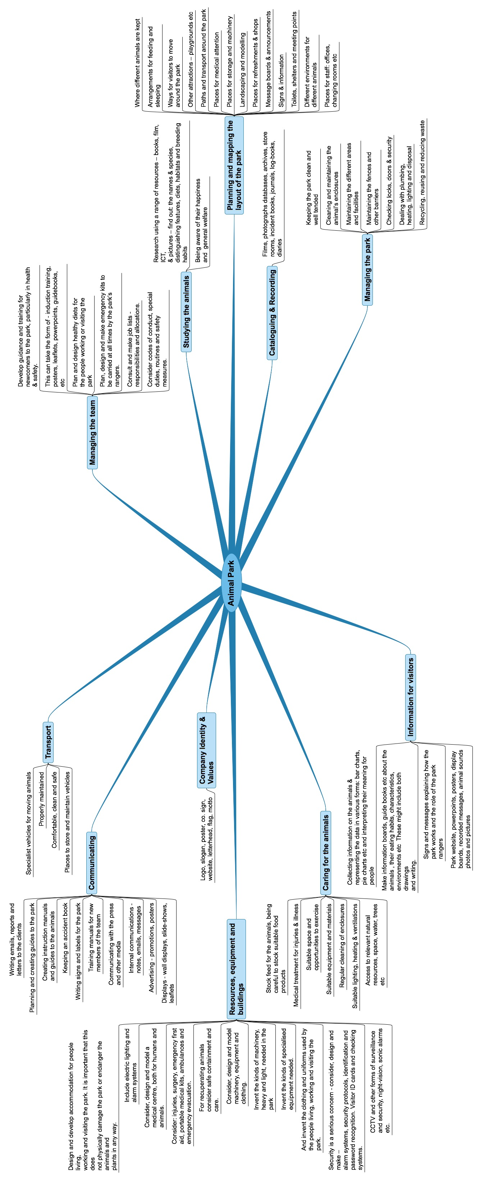

Resources & Links:

1. A map of Colchester zoo available at: http://www.colchester-zoo.co.uk/index.cfm?fa=content.list&page=287&section=7

2. The Animal Card Box – 100 Amazing fact cards – Amazon.co.uk

